NASAL DOUCHING AND HOW TO TAKE YOUR NASAL MEDICATION

This information sheet is designed to help you rinse/wash your nose with salty water and to guide you as to the most effective way to take any nasal medication that has been prescribed.

NASAL DOUCHING

Douching (rinsing the nose with salty water) is important as it keeps the nose clean, washes out mucus, helps reduce inflammation and infection and therefore can help relieve nasal symptoms. It is a safe, natural way to help wash crusts and mucus from your nose. The salty water helps to pull fluid out of any swollen lining of your nose helping you to breathe. This also helps to open up the sinuses.

The following is a solution for you to make at home. All the ingredients are easily available from local shops or supermarkets
Ingredients
½ teaspoon salt
½ teaspoon bicarbonate of soda
½ pint of warm clean water
Method
- Mix the ingredients together
- Fill a large syringe, Neti Pot or the NeilMed Sinus Rinse bottle (see below)
- Stand over a sink or in the shower/bath
- Keep your head straight
- Put the nozzle of the syringe/ bottle in one nostril
- Try to aim the nozzle towards the back of your head
- Squirt half the mixture into one nostril and then repeat on the other side
- The mixture should come into your mouth, spit this out
- If you swallow the mixture, it will do you no harm
- Blow your nose gently
- Rinse your nose in this way two or three times a day
- After douching rinse, the syringe/ bottle in warm, soapy water

Alternative method
Pour some of the solution into the palm of your hand and sniff it up into each
nostril over a sink.
Please note:
This may all feel a bit odd initially and occasionally the mixture may cause some light slight burning, but this should stop in a day or two, so do try to stick with it.

Commercial preparations can be purchased from chemists or over the internet:
- Sterimar Nasal Spray
- NeilMed Sinus Rinse

Neti pots (which look like a very small watering can) can also be used as a very effective delivery system. You can buy it on the internet or from yoga shops!

HOW TO TAKE YOUR NASAL MEDICATION

Taking your nasal medication correctly can be a bit awkward but is vital as it allows it to work properly.
- Blow your nose gently to remove mucus from your nasal passages
- Ideally douche the nose (see above)
- Gently shake the bottle (if using sachets break in half)
- If needed “prime” before using (see instructions with medication)

- Lying on your back on a bed hang your head back over the edge of the bed so you are looking at the bottom of the wall (see next page)

- If using drops or sachets drop the medication into the nose
- If using a spray aim the nozzle toward the back and outer side of your nose making sure to direct the spray straight back, not up into the tip of your nose
- You may have held the bottle ‘upside down’
(so, it is in fact the right way up- see next page!!)
- Gently breathe normally through your nose
- Avoid sniffing, swallowing, sneezing or blowing your nose, if possible, immediately after using the spray

NB- If you are using your nasal spray correctly, the medication should not drip from your nose or down the back of your throat.

GOOD LUCK!!!

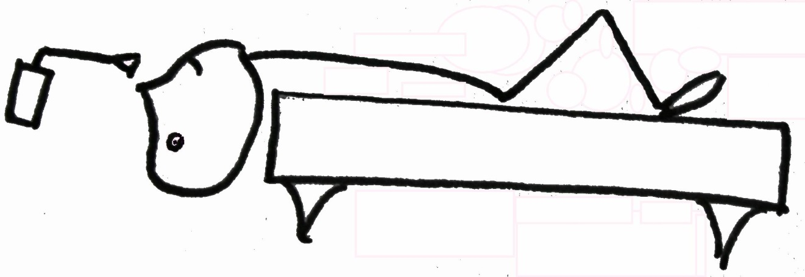
The ‘Bed’ position

